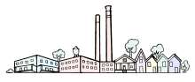
CABBAGETOWN NEIGHBORHOOD IMPROVEMENT ASSOCIATION
177 Estoria Street SE, Atlanta GA 30316 / www.cabbagetown.com / info@cabbagetown.com

To Whom It May Concern,

This letter will confirm the agreement (the “Agreement”) between the Cabbagetown Neighborhood Improvement Association (“CNIA”) and you with respect to the audiovisual material: FULL SET [Cabbagetown Concert Series] featuring the band or performer: ________________________________________________________________ (Artist)
on _____________________________(performance date), including multiple cameras plus one or more external audio sources recorded from the same time & place (the “Material”).

For good and valuable consideration, receipt of which is hereby acknowledged, you hereby grant to CNIA the non-exclusive license and permission to use and reproduce the Material within any and all fundraising campaigns benefiting CNIA, to be distributed by any and all means and media, whether now known or hereafter devised, throughout the universe in perpetuity.

You warrant and represent that you have rights, title, and interest in and to the Material (including copyrights therein); that you have the full right, power and authority to grant CNIA the right to use the Material herein; that no other approvals and/or licenses are necessary for CNIA’s use of the Material as specified herein; and that CNIA’s exercise of such rights shall not violate or infringe upon any rights or any third party.

This Agreement contains the full and complete understanding among the parties hereto with respect to the subject matter hereof and cannot be modified except by a written instrument signed by each party.

If the foregoing is acceptable to you, please so indicate by executing and promptly returning to CNIA the enclosed copy of this letter, in which event it will become a binding grant and license.

Sincerely,
Cabbagetown Neighborhood Improvement Association
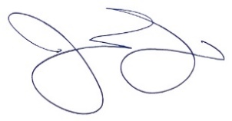
Print Name: John Dirga
Title: Project Director
AGREED TO AND ACCEPTED: [LICENSOR]

By [signature]: ___________________________________________________________________

Print Name: _____________________________________________________________________
Title: ___________________________________________ date signed: _____________________

